**Creating a Virtual Network (VNet) in Azure**

# Step 1: Sign in to the Azure portal

Begin your journey by donning your Azure cape and entering the [Azure Portal](https://portal.azure.com/). This is where the magic happens!

Sign in to the Azure Portal:

* Open your web browser and go to the [Azure Portal](https://portal.azure.com/).
* Sign in with your Azure account.

# Step 2: Navigate to the Virtual Network service

Type “Virtual Network” in the search bar, and select it from the results. The portal unfolds its canvas for your virtual masterpiece.

# Step 3: Create a new virtual network

Click “+ Add” and start configuring the basic settings of your virtual network.

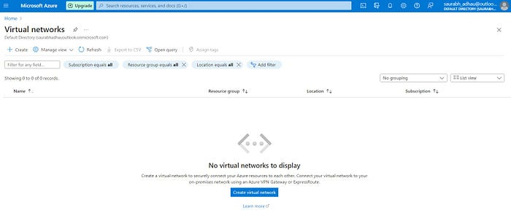

# Step 4: Basic settings

Infuse life into your creation with a name, choose a region that aligns with your strategic goals, and select an existing resource group or craft a new one to house your creation.

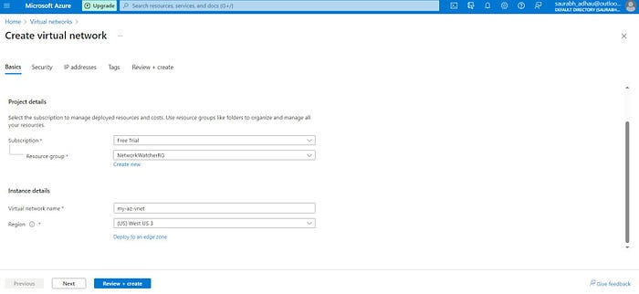

# Step 5: Security settings

Multiple options we have, You can choose anything, then Click on Next.

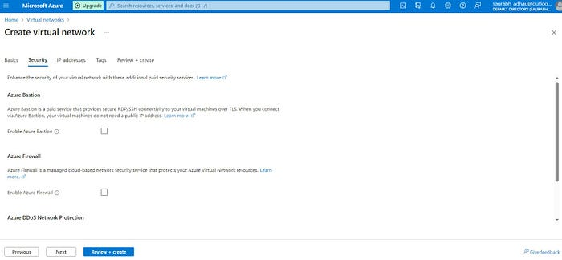

# Step 6: Address space and subnet

Define the IP address range, setting the stage for your virtual network. Subdivide this space into subnets, strategically partitioning your virtual territory.

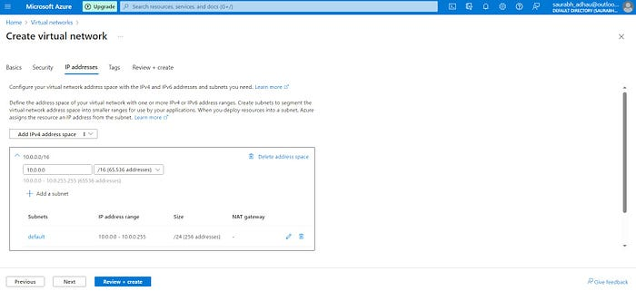

# Step 7: Tagging Telepathy (Optional) 🏷️

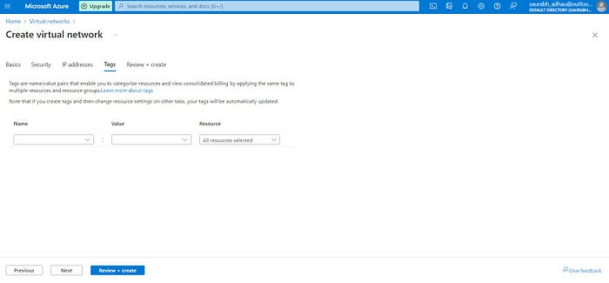

# Step 8: Review + Enchant 🧐

Give your settings a final once-over. Satisfied? Click “Create” to unleash your virtual network into the Azure ecosystem.

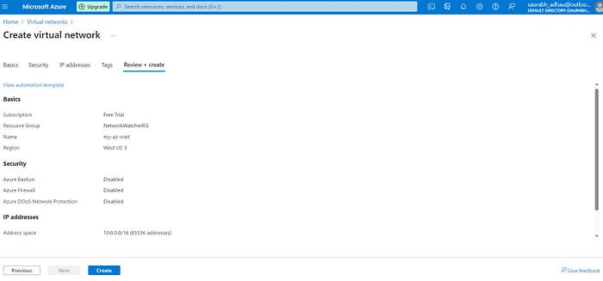

# Step 9: Deployment 💃

## Deployment:

With a click, the deployment process begins. Track the progress in the Azure portal as your virtual network takes shape.

Sit back and enjoy the spectacle as Azure weaves its deployment magic. Soon, your new virtual companion will be ready to join you on your digital adventures.

Congratulations, oh Azure Conjurer! Your Azure Virtual Network (VNet) is now a reality, ready to serve you in the vast digital realms. 🌐🔮

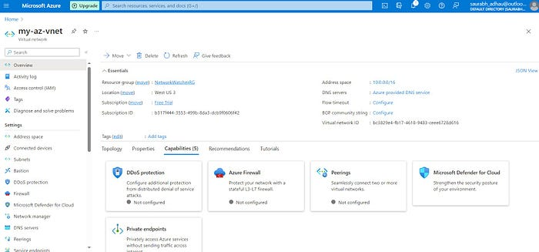

In conclusion, creating a virtual network in Azure is not just a setup task; it’s an opportunity to architect a robust and scalable foundation for your applications. Whether you navigate the Azure Portal’s intuitive interface or command Azure PowerShell with finesse, you are shaping the digital future of your infrastructure. Happy networking in the Azure cloud!